IBM Cognos Analytics – Dashboarding Workshop

Prerequisites: IBM Cloud Account. See the Setup and Installation Guide for more details.

IBM Cognos Analytics provides users with data discovery capabilities to visually explore and interact with their data to identify the key insights for improving data driven decisions. Users can perform data discovery and then quickly assemble that information which is most relevant to them into interactive, visually appealing dashboards. In this tutorial, you will experience the following capabilities in Cognos Analytics:

1. Working with Visualisations
2. Assembling a Dashboard
3. Using the Assistant

Start by finding **Cognos Analytics** (<https://www.ibm.com/products/cognos-analytics> ) through your browser and log in with your IBM Cloud account. On the home page, **upload the data file titled “CustomerLoyaltyProgram_Full.csv**” with either the browse or drag-and-drop method. When the file appears uploaded on the page in front of you, click to open your file and the **Layout** selection screen will appear.

Part 1: Working with Visualisations

1. 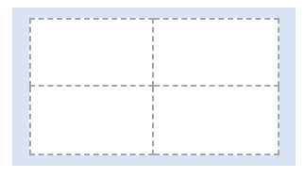From the Layout selection screen, select the **tabbed dashboard** style. Then select the **four-panel template with a 2x2 configuration** (see image). Click OK.
2. The dashboard template we have selected will open on the Canvas in front of you. If it is not already open, select **Sources** from the Navigation Panel on the left. You should be able to see your file name here.
3. From the dropped down menu of the Data Source panel, hold down **Ctrl (or Command on Mac) and select** the “Product Line”, “Coupon Response”, and “Quantity Sold” options.
4. Now **drag the selected items** on to the icon in the centre of the top left dashboard panel and **drop them** when it turns blue.

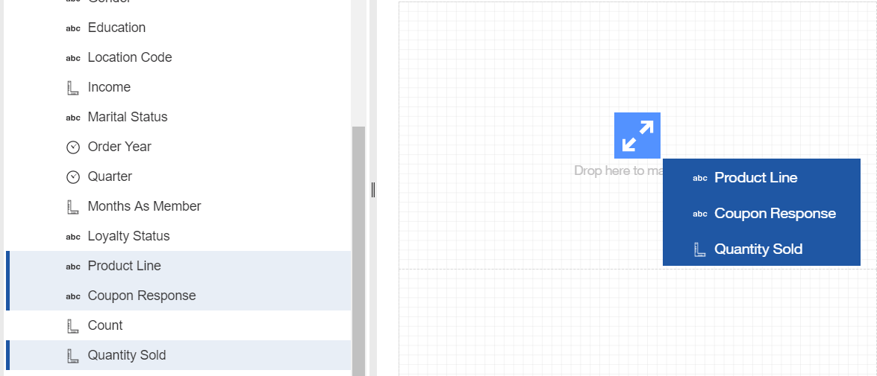

1. Once the data visualisation has rendered, **click on it** to bring up the toolbar that appears on the right, then click on the **Change Visualisation** icon to open the Visualisation library.
2. 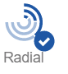In this Visualisation library, expand the **All Visualisations** tab, scroll down, and select the **Radial** chart.
3. Once the visualisation has updated to a Radial chart, click the **Expand Window** button in the top left corner of the chart to take you to “Design Mode”.
4. 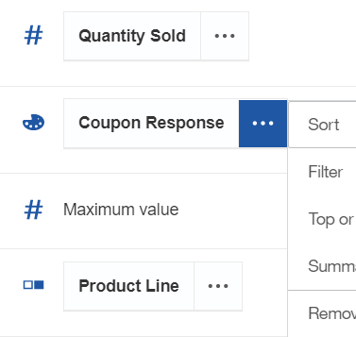Drag and drop the **Product Line** box to the **Repeat (column)** field, then take the **Coupon Response** box to the **Color** field.
5. Click the ellipses menu on the **Coupon Response** box, select Sort, then **Sort Ascending**.
6. Now collapse the window, click the **Save** icon, and save your dashboard under the **My Content** tab.

Part 2: Assembling a Dashboard

Step 1: Bubble Chart

1. From the **Navigation** panel on the left, select the **Visualisations** library.
2. Choose the **Bubble** chart, then **drag** it to the icon in the panel below your first chart and **drop** it when the icon turns blue.
3. **Drag-and-drop** the following items from the data source panel on the left into their associated data slots in the Design Mode window.
   * Quantity Sold 🡪 X Axis
   * Unit Sale Price 🡪 Y Axis
   * Revenue 🡪 Size
   * Product Line 🡪 Color
4. **Collapse** the Design Mode window.

Step 2: Packed Bubble Chart

1. From the **Navigation** panel on the left, select the **Visualisations** library.
2. Choose the **Packed Bubble** chart, then **drag** it to the icon in the panel to the right of your first chart and **drop** it when the icon turns blue.
3. **Drag-and-drop** the following items from the data source panel on the left into their associated data slots in the Design Mode window.
   * Product Line 🡪 Bubbles
   * Quantity Sold 🡪 Size
   * Loyalty Status 🡪 Color
4. **Collapse** the Design Mode window.

Step 3: Stacked Column Chart

1. ****From the **Navigation** panel on the left, select the **Visualisations** library.
2. Choose the **Stacked Column** chart, then **drag** it to the icon in the bottom-right panel and **drop** it when the icon turns blue.
3. **Drag-and-drop** the following items from the data source panel on the left into their associated data slots in the Design Mode window.
   * Order Year 🡪 Bars
   * Quantity Sold 🡪 Length
   * Product Line 🡪 Color
4. **Collapse** the Design Mode window.
5. **Save** your dashboard.

Part 3: Using the Assistant

1. From the **Navigation** panel on the left, click the **New** button, then click **Dashboard**.
2. Select the **blank template (with no panels)** and click the **OK** button.
3. Click the **Assistant** icon in the **Navigation** panel.
4. In the **Ask a Question** field, type “**load source customer loyalty**”, and press Enter.
5. Select your data file, **CustomerLoyaltyProgram_Full.csv**, from the search results.

The Assistant will render a list of fields from the data source where it has identified relevant concepts that you may be interested in for your analysis. For instance, it shows fields that have outliers in the data and recognizes fields which are identifiers, expenses, revenues and so on.

1. In the **Ask a Question** field, type “**what is my revenue by product line?**”, and press Enter.

The Assistant will analyze the question and provide an Insight to answer the question with best match. Matching is done based on a full match of column names, partial column names and concept matching (e.g. Revenue vs Sales as these conceptually can be related and someone interested in revenue may also be interested in sales).

1. In the **Ask a Question** field, type “**what is the quantity sold by product line and year?**”, and press Enter.
2. Click the **right arrow** icon until the chart displayed matches the attached picture below.

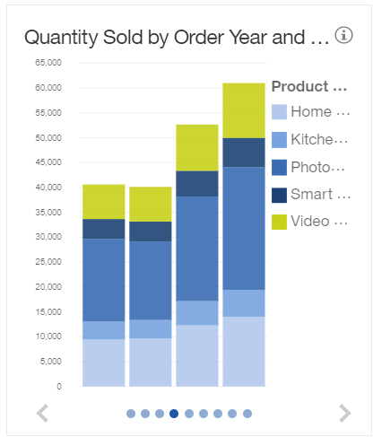Over the course of this workshop, we’ve put together bubble charts, radial charts, stacked column charts, and more. We’ve put them together in a simple and digestible format that displays our data in way that data scientists and business people alike can understand. The data here is unrefined, but there are many ways this could be taken further and deeper from an analytics perspective. Additionally, we’ve examined how to use the Assistant to work faster with our data.